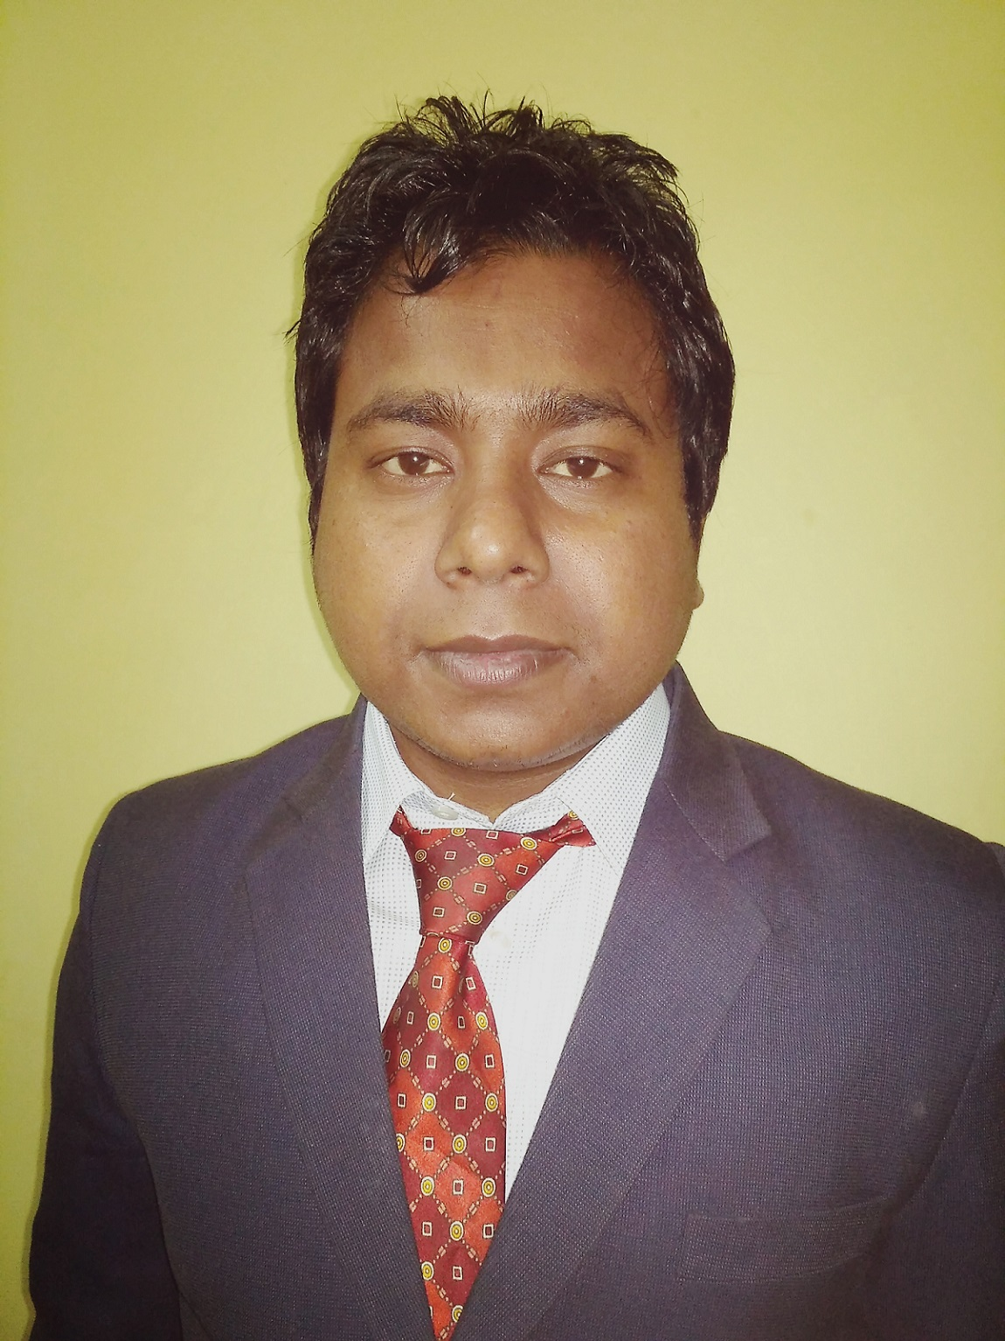
ADDRESS
H.-6A, Shakarpur
New Delhi - 110092
Mobile No.-+91-9911886424
capurushottamsah@gmail.com
CA PURUSHOTTAM KUMAR SAH

CAREER OBJECTIVE

To work in a challenging business environment and make a meaningful contribution to the competitiveness and value of the organization at large which in turn helps me in achieving my goals.

PROFESSIONAL QUALIFICATION

- Passed CA Final in Nov. 2016 with 53%.
- Passed C.A. I.P.C.C (Both Groups) in May 2012 with 62%.
- Passed C.A. C.P.T in Dec, 2010 with 58%.

ACADEMIC QUALIFICATION

- Passed Graduate {B.COM (A&F)} from IGNOU with 60%.
- Passed 12th from Tribhuvan University of Nepal (T.U.) in 2010 with 51%.
- Passed 10th from S.L.C Board of Nepal in 2008 with 64%.

COMPUTER PROFICIENCY
- Conversant with accounting packages like Tally, Busy (version o7, 09, erp9)
- Proficient in working with MS-Office Applications earlier version and currently working with MS-Office Application 2013.
- Successfully completed 100 hours Information Technology Training (ITT) Course held by ICAI.
- Completed Basic Computer Course.
- Diploma in accounting package (tally, fact, exactly gold, Accman & swastika)

COMMUNICATION SKILL

- Successfully Completed Fifteen days of General Management and communication skill (Gmcs-1) held by ICAI.
- Successfully Completed Fifteen days of General Management and communication skill (GMCS-2) held by ICAI.

WORKING-EXPERIENCE
- Six months working experience in M/S Deepak Batra and Associates, as Article Assistant in C.A firm (from September 2012 to Feb 2013).
- Thirty months working experience in M/S P.N. Arora & co, as Article Assistant in C.A firms (from March 2013 to Sept 2015).
- Five months working experience in M/S J.K. VERMA & CO as Audit Assistant (from Dec 2015 to April 2016).
Key assignment handled during the article ship & Job holder.

- Statutory Audit.
- Compliance with the requirements of Schedule III to the Companies Act 2013, Old & Revised Schedule VI of the Companies Act 1956 and other relevant provisions & rules thereon.
- Compute and review Depreciation under Schedule II of the Companies Act 2013.
- Compliance with the relevant Accounting Standards & Standards on Auditing.
- Compliance with the requirements of the Income Tax Act, 1961 & the Income Tax Rules, 1962.
- Verification of cash and stock.

- Secretarial Work
1. Company incorporation, DIN registration, DSC registration, Appointment and retirement of director.
2. Compliance with ROC (e.g. Preparation of information for a form, filing and e-filing with Roc).
- Taxation.
- Preparation of Income Tax computation of Individuals, Firms and Companies & e-filling.
- Computation, reconciliation and payment of TDS, TCS, Services Tax and Sales Tax.
- Preparation and e-filling of TDS and TCS returns along with TDS.
- Preparation of book as per income tax and income tax audit as per income tax laws.
- Compliance of service tax, computation of taxable services, service tax amount e-filing & registration.
- Preparation of reply for submission for scrutiny assessments u/s 143(3).
- Administrative assistance on matters such as Permanent Account Number, and Refund Orders.
- Preparation of Form 3CD & 3CA /3CB under the Income Tax Law.

- Stock Audit.

- Stock taking of big bazar, future groups.
- Physical verification of stock audit and preparation of stock audit reports.
- Preparation of stock statements, cash credit for the given period and arrive a drawing power.
- Miscellaneous.
- Books of account maintenance of different assesses under the Income Tax Act, 1961.
- Preparation and presentation of Financial Statements under Companies Act, 2013.
- Registration of trust under section 12AA of the Income Tax Act, Partnership, proprietorship firms.
- Prepare Replies of Notices under the Income Tax Act & service tax.
- Ledger scrutiny and creating and evaluation of provisions.
- Monitoring and ageing of trade receivables & trade payables.

PERSONAL DETAILS

Father’s Name : Ram Pukar Prasad Sah
Date of Birth : 7-Jan-1992.
Languages Known : English, Hindi, Nepali, Maithili and Bhojpuri.
Nationality : Nepalese.
Interests : Travelling & suffering on internet to get new thinngs.
Marital Status : Unmarried.
I, PURUSHOTTAM KUMAR SAH, do acknowledge that the all information given above is true and will be ready to supply original documents on this behalf if required by you any time.
Place: New Delhi
Date: 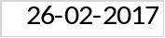 (Purushottam Kumar Sah)

